**The Calendar Apps**



Name: Lam Min Yi

Student ID: 17098370

Table of Contents

Report Chapter 1: Expert Testing 3

Section 1.1: My SUS Scores 4

Section 1.2: My Qualitative Reflections 8

Calendar 8

Google Calendar 9

PocketLife Calendar 10

Section 1.3: My Heuristic Evaluations 11

Calendar 11

Google Calendar 13

PocketLife 15

Report Chapter 2: Prototyping 17

Section 2.1: My Vision 17

2.1.1 Functionality 17

2.1.2 Design 18

Section 2.2: My Test Plan 19

Section 2.3: My Low-level Prototype 20

# Report Chapter 1: Expert Testing

The chapter will discuss some relevant existing apps that currently available in the market and analyse them in detail. There will be three sections in this chapter which are:

* **My SUS Scores**

Using quick and dirty evaluations to create a relevant shortlist

* **My Qualitative Reflection**

Reflect on the functionality offered by each app

* **My Heuristic Evaluations**

Evaluate the design of each app

By analysing these existing apps, both positive and negative part will be deliberate and guide me to do the second prototyping chapter.

## Section 1.1: My SUS Scores

There are thousands of calendar apps available in Apple store, but only the top five or highest download rate of the calendar apps is chosen and downloaded in the phone to investigate the pros and cons. Five apps are under consideration which are:

1. Calendar (Apple default app)

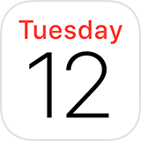

1. Calendars by Readdle



1. Google Calendar



1. Countdown - Calendar (Lite)

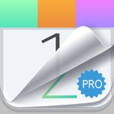

1. PocketLife Calendar



**System usability scale**, SUS analysis is used to get a “quick-and-dirty” impression of each app, and formulas are generated in an Excel spreadsheet to calculate the SUS score for each app. The spreadsheet contains ten questions from the SUS, and the user is allowing to enter the score (1= strongly disagree; 5= strongly agree) against each item. The designed formulas will calculate the overall SUS score from the entries (0-100). The odd number (1,3,5,7 and 9) are positive questions while even number (2, 4, 6, 8 and 10) are negative questions. To calculate the SUS score, first sum the score from each item. For items **1,3,5,7 and 9,** the score contribution is the scale position **minus 1**. For the rest **2,4,6,8, and 10** the input will be **5 minus** the scale position.

At last, **multiply** the sum of the scores by **2.5** to get the total value of SUS. The overall amount that above 68 will be indicated as green, while below 68 will show as red. There are ten questions will be asked in SUS analysis.

The results are collected as shown below.

1. Calendar (95%)



Figure 1 SUS analysis for Calendar.

1. Calendar by Readdle (25%)



Figure 2 SUS for calendar by Readdle.

1. Google Calendar (93%)



Figure 3 SUS for Google Calendar.

1. Countdown -Calendar (Lite) (53%)



Figure 4 SUS for Countdown -Calendar (Lite).

1. PocketLife Calendar (55%)



Figure 5 SUS for PocketLife Calendar.

Apple default apps, Calendar and Google Calendar ranked top two, while Calendar by Readdle ranked the last among the apps. The graph below shows the results of SUS analysis.

Figure 6 Comparison between apps.

Top 3 apps have been selected and will be used as a reference in later sections which are **Calendar, Google Calendar, and PocketLife Calendar.**

## Section 1.2: My Qualitative Reflections

### Calendar

Theme 1: iCloud Calendar can scan iMessage and emails for the appointment. (it saves user time to open the app and create an event, in case the user forgets to create for it)

Theme 2: The app supports multiple accounts with one calendar, manage the events in Calendar, even if they are in different accounts like iCloud or Google. (support customisation, allow the user to differentiate personal and business use)

Theme 3: User can create separate calendars for different areas of life, spot work, family or personal events. (support customisation, quick glance as the user can change the colour of every event)

Theme 4: Invite and be invited into the event. Set up events and send Calendar invitations to friends and co-workers. (user able to know who is attending the event)

Theme 5: Add the location of the event, such as the name of a restaurant. The calendar fills in the address, and it will show a map and the weather and let you know when it is time to leave. (save time, the user can get notification one day before or 1 hour before they need to move)

Theme 6: No passcode. (privacy concern)

Theme 7: Only one alert sound available. (user does not know either is birthday, meeting, or holiday alert.)

Theme 8: Not printable (how if the mobile run out of battery?)

### Google Calendar

Theme 1: When user gets an email about an event such as flight, hotel, restaurant booking etc., it will be added into the calendar automatically. (it saves user time to open the app and create an event, in case the user forgets to create for it)

Theme 2: The app supports multiple accounts with one calendar, manage the events in Calendar, even if they’re in different accounts like iCloud or Google. (support customization, allow the user to differentiate personal and business use)

Theme 3: Schedule with different images. Can change holidays between countries and support specific calendar such as Chinese Lunar calendar, Muslim etc. (support customization, it makes the user easier to see what’s ahead with the images and the maps)

Theme 4: Invite and be invited into the event. (user able to know who is attending the event and what to prepare)

Theme 5: Location and notification setting. (User can set meeting location, and notification before the even start)

Theme 6: User able to set private or public event, but no passcode required. (privacy concern)

Theme 7: Only one alert sound available. (user does not know either is birthday, meeting, or holiday alert.)

Theme 8: Not printable on mobile, only available on the web. (user can’t track the schedule if mobile device run out of battery)

Theme 9: Smart suggestions. The user does not need to type the title, the calendar helps to create events in just a few letters for event titles, people and places. (save time for the user to type)

### PocketLife Calendar

Theme 1: Do not support sync function. (Which means every new event have to create manually)

Theme 2: It is allowing to display multiple calendars (notify the user about the holidays worldwide, TV shows from some countries, or get weather from a different city), but it does not support multiple accounts. (it will bring confusedness to the user to identify events between business and personal used.)

Theme 3: Customisable pictures for calendar months display (high contrast images are provided)

Theme 4: Share calendars with colleagues, friends and family (user able to know who is attending the event and what to prepare.)

Theme 5: Import own images from photos (match between system and the real world)

Theme 6: Passcode protection (privacy concern solves)

Theme 10: Personalize the colour, fonts and pictures of the display. (suitable for all generation, for example senior citizens, but multiple pictures and colour may look busy to person’s eye)

## Section 1.3: My Heuristic Evaluations

This section will relate the design of each app with the respect of Nielsen’s heuristics.

### Calendar

|  |  |  |
| --- | --- | --- |
|  |  |  |
| Figure 1.3.1 | **Figure 1.3.2** | **Figure 1.3.3** |
|  |  |  |
| Figure 1.3.4 | **Figure 1.3.5** |  |

Observation 1: Consistency and standard

The app demonstrated good adherence to Nielsen’s 1st heuristic by showing the calendar in the grid system. Monthly calendars are displayed clearly and tidy. But the functions separated at the top and bottom of the apps. (screenshot in Figure 1.3.1 and 1.3.4)

Observation 2: Match between system and real world

The app demonstrated good adherence to Nielsen’s 3rd heuristic by letting the user choose a different calendar. (screenshot in Figure 1.3.2)

Observation 3: User control and freedom

The app violates Nielsen’s 5th heuristic. The user is unable to redo or undo the mistake.

Observation 4: Error prevention

The app demonstrated good adherence to Nielsen’s 4th heuristic by using showing a good error message when the user wants to delete event. (screenshot in Figure 1.3.5)

Observation 5: Recognition rather than recall

The app violates Nielsen’s 5th heuristic by using less icon. The functions separated in the top and bottom navigation bar. Combination or word and icons make user confuse. Besides that, icon is rarely used, excessive button to access the function. (screenshot in Figure 1.3.4)

Observation 6: Aesthetic and minimalist design

The app demonstrated good adherence to Nielsen’s 8th, no excessive other functions in the apps. Only has one background theme. Preference for small and faint text, minimal colour makes it very chaotic. The user may miss an event because it didn’t catch user’s eyes. (Figure 1.3.4)

Observation 8: Provide online documentation and help

The app demonstrated good adherence to Nielsen’s 10th by providing online documentation and help in <https://support.apple.com/en-gb/HT202337>

### Google Calendar

|  |  |  |
| --- | --- | --- |
|  |  |  |
| Figure 1.3.6 | **Figure 1.3.7** | **Figure 1.3.8** |
|  |  |  |
| Figure 1.3.9 | **Figure 1.3.10** | **Figure 1.3.11** |

Observation 1: Consistency and standard

The app demonstrated good adherence to Nielsen’s 1st heuristic by showing all the functions in the same spot. All the functions clearly seen by the user. (screenshot in Figure 1.3.6)

Observation 2: Visibility of system status

The app demonstrated good adherence to Nielsen’s 2nd heuristic. The calendar shows everyday events clearly with a different colour. (screenshot in Figure 1.3.7)

Observation 3: Match between system and real world

The app demonstrated good adherence to Nielsen’s 3rd heuristic by letting the user choose a different calendar. (screenshot in Figure 1.3.8)

Observation 4: User control and freedom

The app violates Nielsen’s 5th heuristic. The user is unable to redo or undo the mistake.

Observation 5: Error prevention

The app demonstrated good adherence to Nielsen’s 4th heuristic by using showing a good error message when the user wants to delete event. (screenshot in Figure 1.3.9)

Observation 6: Recognition rather than recall

The app demonstrated good adherence to Nielsen’s 4th heuristic by using the appropriate icon for every function. (screenshot in Figure 1.3.10) Icons are used correctly.

Observation 7: Aesthetic and minimalist design

The app demonstrated good adherence to Nielsen’s 8th, no excessive other functions in the apps. Colourful, spaced-out style makes even a particularly packed schedule look tidy and organised across every page of the mobile app.

Observation 8: Provide online documentation and help

The app demonstrated good adherence to Nielsen’s 10th by providing online documentation and help. (screenshot in Figure 1.3.11)

### PocketLife

|  |  |  |
| --- | --- | --- |
|  |  |  |
| Figure 1.3.12 | **Figure 1.3.13** | **Figure 1.3.14** |
|  |  |  |
| Figure 1.3.15 | **Figure 1.3.16** | **Figure 1.3.17** |

Observation 1: Consistency and standard

The app demonstrated good adherence to Nielsen’s 1st heuristic by showing all the functions in the same spot. The user sees all the functions. (screenshot in Figure 1.3.12)

Observation 2: Visibility of system status

The app demonstrated good adherence to Nielsen’s 2nd heuristic. The calendar shows everyday events clearly with a different colour, the user can even change the background of the schedule to indicate the mood of the month. (screenshot in Figure 1.3.12)

Observation 3: Match between system and real world

The app demonstrated good adherence to Nielsen’s 3rd heuristic by letting user choose different calendar. (screenshot in Figure 1.3.13)

Observation 4: User control and freedom

The app demonstrated good adherence to Nielsen’s 3rd heuristic by letting the user redo or undo the delete action. (screenshot in Figure

Observation 5: Error prevention

The app demonstrated good adherence to Nielsen’s 4th heuristic by using showing good error message when user wants to delete event. (screenshot in Figure 1.3.14)

Observation 6: Recognition rather than recall

The app demonstrated good adherence to Nielsen’s 4th heuristic by using the appropriate icon for every function. (screenshot in Figure 1.3.13 and 1.3.15)

Observation 7: Aesthetic and minimalist design

The app violates Nielsen’s 8th heuristic. It has a sound effect when user changing the pages such as open the menu bar etc., high contrast pictures are used as the theme of the background caused the apps to look messy. But user able to change font size etc. (screenshot in Figure 1.3.16)

Observation 8: Provide online documentation and help

The app demonstrated good adherence to Nielsen’s 10th by providing online documentation and help. (screenshot in Figure 1.3.13)

# Report Chapter 2: Prototyping

## Section 2.1: My Vision

### Functionality

My app will

* Allow auto sync email adds the event will automatically create in the calendar, preserving **Theme 1**
* support multiple accounts preserving **Theme 2**
* support multiple countries calendar preserving **Theme 3**
* invite and be invited into the event preserving **Theme 4**
* Support location and notification setting preserving **Theme 5**
* Passcode protection addressing (login form) **Theme 6**
* Allow customise sound effect addressing **Theme 7**
* Allow print function and email addressing **Theme 8**
* Support smart suggestion preserving **Theme 9**
* Allow user to personalise colour and fonts enhancing **Theme 10**
* Allow user to add item into grocery basket

### Design

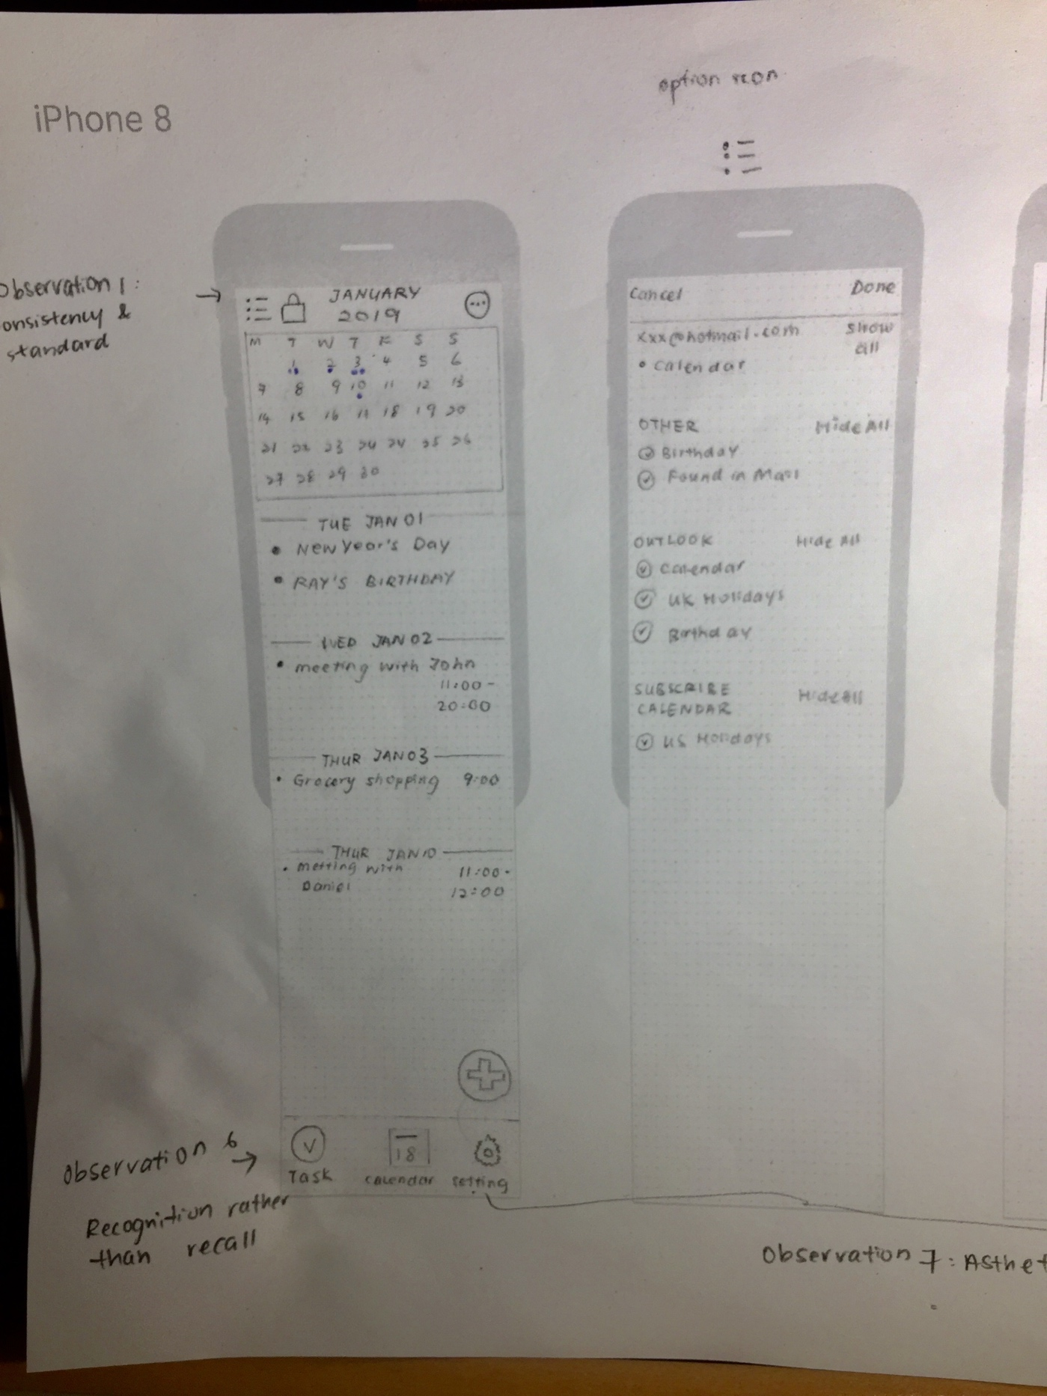

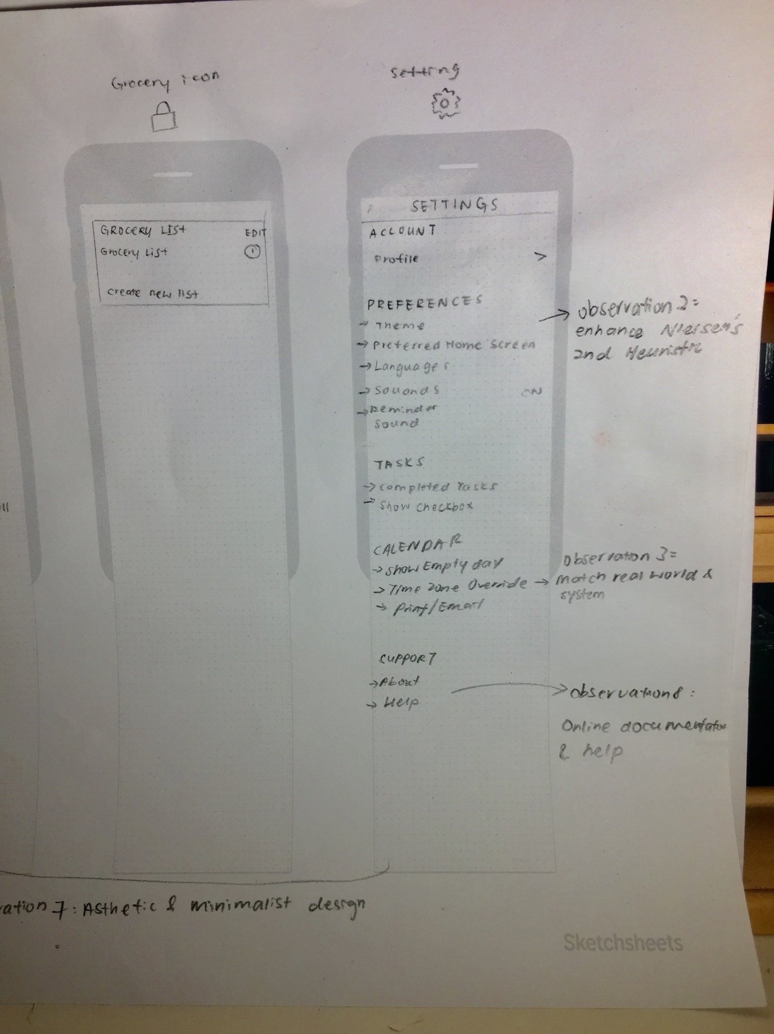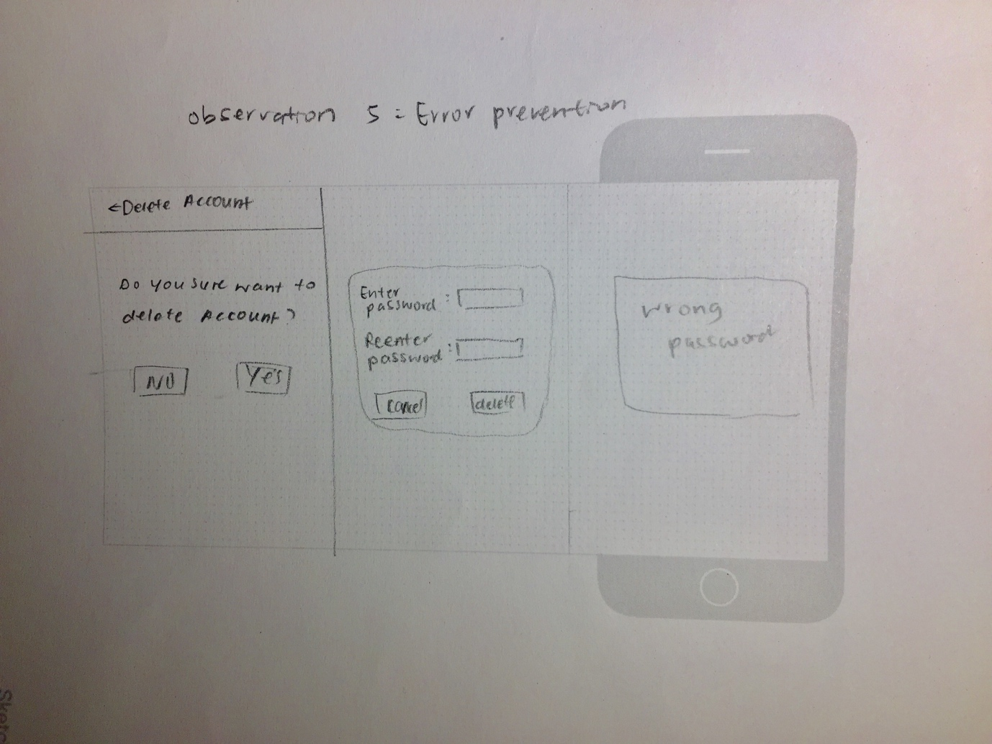

## Section 2.2: My Test Plan

**Scenario 1**: You just log out from the app, and you need to log in to use the app

Task: Sign in the app by using default

email: [mandy@hotmail.com](mailto:mandy@hotmail.com)

password: password

**Scenario 2**: You have changed a new email

Task: Change your current email to new email

Instruction: Login > Setting > Profile > (a pencil beside name and email) > fill in and click update

**Scenario 3**: You got a meeting with Angeline

Task: Create a new event on 2nd February and remember to invite Angeline to the meeting

Instruction: Calendar > “+” button at the right corner > Event icon > filled up > Done.

## Section 2.3: My Low-level Prototype

https://ft55y0.axshare.com/#c=2